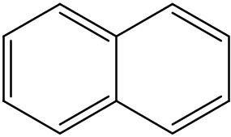

pasted naphthalene from chemdraw

